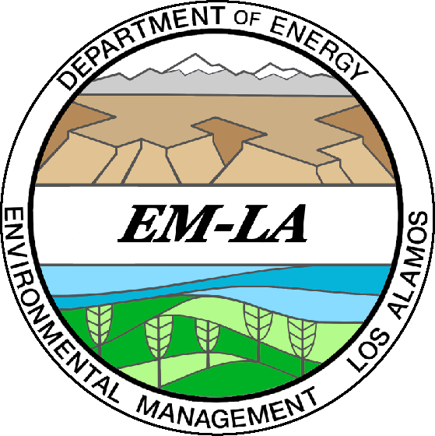Agenda

Individual Permit Public Meeting
WebEx Meeting
June 16, 2021
2-4 p.m.

2 p.m. Meeting Instructions Kate Keenan, N3B
Regulatory & Stakeholder Interface

2:05 p.m. Welcome David Nickless, EM-LA
Director, Completion Project Delivery

2:10 p.m. Draft Permit Update and Amanda White, N3B/T2S
Monitoring Plan Overview Program Manager, Watershed Monitoring and Technical Services

2:30 p.m. Communities for Clean Water Update Rachel Conn, Communities for
Clean Water

2:45 p.m. Proposal for Site-specific Copper Water Barry Fulton, N3B/Windward
Quality Criteria Environmental, LLC
Principal Scientist

3:10 p.m. Enhanced Controls - 2021 Plans Susan Lime, N3B/T2S
Project Engineer

3:30 p.m. Questions and Answers

Produced by N3B Los Alamos, the Los Alamos Legacy Cleanup Contractor, on behalf of DOE’s Environmental Management Los Alamos Field Office.

